- What is class loader?
ClassLoader is a class in java which dynamically loads Java classes into the Java Virtual Machine (In other words, ClassLoaders are used to load classes at runtime.). Java code is compiled into class file by javac compiler and JVM executes Java program, by executing byte codes written in class file. Usually these class files are only loaded on demand. ClassLoader is responsible for this on demand loading of class files from file system, network or any other source. Correct understanding of class loader is must to resolve issues like NoClassDefFoundError in Java and java.lang.ClassNotFoundException, which are related to class loading.
ClassLoader in Java works on three principle: delegation, visibility and uniqueness.
- Delegation: Delegation principle forward request of class loading to parent class loader and only loads the class, if parent is not able to find or load class. (All class loaders except bootstrap class loader has a parent class loader. This parent is not as in parent-child relationship of inheritance. Every class loader instance is associated with a parent class loader. When a class loader instance is created, using its constructor the parent classloader can be associated with it.)
- Visibility: Visibility principle allows child class loader to see all the classes loaded by parent ClassLoader, but parent class loader can not see classes loaded by child.
- Uniqueness: Uniqueness principle allows to load a class exactly once, which is basically achieved by delegation and ensures that child ClassLoader doesn't reload the class already loaded by parent.
There are three default class loaders used in Java: Bootstrap or Premordial , Extension and System or Application class loader. Every class loader has a predefined location, from where they loads class files.
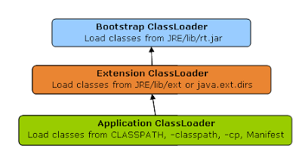

Bootstrap class loader or Primordial class loader:
- It is the parent of all class loaders in java. It is native implementation mostly in C which may differ across different JVMs. (All other Java class loaders are extended from java.lang.ClassLoader.)
- It loads classes of core java API like java.lang, java.util, etc from rt.jar (rt.jar stands for runtime JAR). These are classes that are part of java runtime environment.
- When a java source file is compiled to a binary class, compiler inserts a field into the generated class file. It is a public static final field named ‘class’ of type java.lang.Class. Thats why, for all java classes you can access it as java.lang.Class classObj = ClassName.class;
This ClassName.class contains a method getClassLoader() which returns the class loader for the class. getClassLoader() will return null it it was loaded by bootstrap class loader.
Extension class loader:
- Its parent is Bootstrap ClassLoader (Bootstrap or Primordial class loader is parent of Extension class loader delegation hierarchy wise and not inheritance wise. Inheritance wise all class loaders except bootstrap class loader are extended from java.lang.ClassLoader).
- jre/lib/ext contains jar packages that are extensions of standard core java classes.
- Using the system environment propery java.ext.dirs you can add ‘ext’ folders and jar files to be loaded using extensions class loader.
- Extension ClassLoader delegates class loading request to its parent, Bootstrap and if unsuccessful, loads class form jre/lib/ext directory or any other directory pointed by java.ext.dirs system property.
- Extension ClassLoader in JVM is implemented by sun.misc.Launcher$ExtClassLoader.
System or Application class loader:
- Its parent is Extension ClassLoader (Extension class loader is parent of System or Application class loader delegation hierarchy wise and not inheritance wise. Inheritance wise all class loaders except bootstrap class loader are extended from java.lang.ClassLoader).
- Third default class loader used by JVM to load Java classes is called System or Application class loader and it is responsible for loading application specific classes from CLASSPATH environment variable, -classpath or -cp command line option, Class-Path attribute of Manifest file inside JAR.
- Application class loader is a child of Extension ClassLoader and its implemented by sun.misc.Launcher$AppClassLoader class.
Except Bootstrap class loader, which is implemented in native language mostly in C, all Java class loaders are extended from java.lang.ClassLoader. You can see more class loaders like java.net.URLClassLoader, java.security.SecureClassLoader etc.
How many times a class can be loaded by the class loader?
A class is loaded only once into the JVM. In this rule, what is “a class”? Uniqueness of a class is identified along with the ClassLoader instance that loaded this class into the JVM. A class is always identified using its fully qualified name (package.classname). So when a class is loaded into JVM, you have an entry as (package, classname, classloader). Therefore the same class can be loaded twice by two different ClassLoader instances.
How class loader works in java?
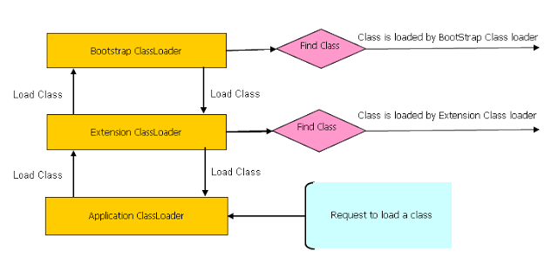
Delegation principle: Suppose you have an application specific class called Abc.class. First request of loading this class will come to Application ClassLoader which will delegate to its parent Extension ClassLoader which further delegates to Primordial or Bootstrap class loader. Primordial will look for that class in rt.jar and since that class is not there, request comes to Extension class loader which looks on jre/lib/ext directory and tries to locate this class there, if class is found there than Extension class loader will load that class and Application class loader will never load that class but if its not loaded by extension class-loader then Application class loader loads it from Classpath in Java. If it is not found even at the locations mentioned in the Classpath variable, then java.lang.ClassNotFoundException is thrown. Remember Classpath is used to load class files while PATH is used to locate executable like javac or java command.
Visibility principle: According to visibility principle, Child ClassLoader can see class loaded by Parent ClassLoader but vice-versa is not true. Which mean if class Abc is loaded by Application class loader than trying to load class ABC explicitly using extension ClassLoader will throw either java.lang.ClassNotFoundException. But as java.lang.String class is loaded by the bootstrap class loader, so it can again be loaded by the extension ClassLoader. See project: ClassLoaderTest (Just see the custom implementation of ClassLoader).
Uniqueness principle: According to this principle a class loaded by Parent should not be loaded by Child ClassLoader again. Though its completely possible to write class loader which violates Delegation and Uniqueness principles and loads class by itself, its not something which is beneficial. You should follow all class loader principle while writing your own ClassLoader.
How to load class explicitly in java?
Java provides API to explicitly load a class by Class.forName(classname) and Class.forName(classname, initialized, classloader). You can pass name of ClassLoader which should be used to load that particular class. Class is loaded by calling loadClass() method of java.lang.ClassLoader class which calls findClass() method to locate bytecodes for corresponding class. If findClass() does not found the class than it throws java.lang.ClassNotFoundException and if it finds it calls defineClass() to convert bytecodes into a .class instance which is returned to the caller.
Where to use ClassLoader in java (ClassLoader in Java is a powerful concept and is used at many places):
- One of the popular example of ClassLoader is AppletClassLoader which is used to load class by Applet, since Applets are mostly loaded from internet rather than local file system.
- By using separate ClassLoader you can also loads same class from multiple sources and they will be treated as different class in JVM.
- J2EE uses multiple class loaders to load class from different location like classes from WAR file will be loaded by Web-app ClassLoader while classes bundled in EJB-JAR is loaded by another class loader.
- Some web server also supports hot deploy functionality which is implemented using ClassLoader.
- You can also use ClassLoader to load classes from database or any other persistent store.
- Suppose we want to use two different versions of our jar in our application. Means we want some of the files from one jar and some of the files from the other jar. Definitely the fully qualified names of the files in these two versions of jar will also be same. In that case, we will need our own custom class loader which can load some of the files from one jar and some other files from the other jar.
- We need to override only loadClass() method to create our custom ClassLoader. Its constructor is used to associate the parent ClassLoader with it.

